**3. ReactJS-HOL**

The objective of this HandsOn is to create a react app for Student Management Portal named scorecalculatorapp and create a function component named “CalculateScore” which will accept Name, School, Total and goal in order to calculate the average score of a student and display the same.

**Steps followed :**

1. Created the React App –

I created a new React app ‘scorecalculatorapp’ using command in command prompt :

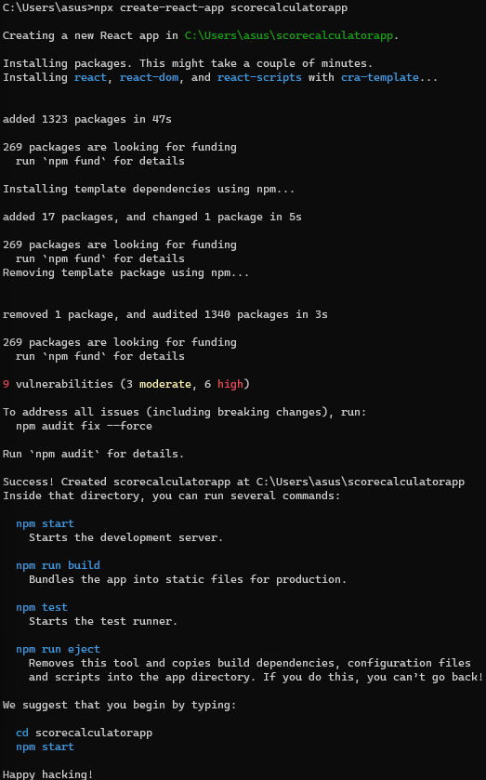

1. Created Components folder and file CalculateScore.js –

I created a folder ‘Components’ in src and inside it, I created a file ‘CalculateScore.js’ which contains the following code :

import '../Stylesheets/mystyle.css';

const percentToDecimal = (decimal) => {

return (decimal.toFixed(2) + "%");

}

const calcScore = (total, goal) => {

return percentToDecimal(total / goal);

}

export const CalculateScore = ({ Name, School, total, goal }) => (

<div className="formatstyle">

<h1><font color="Brown"> Student Details: </font></h1>

<div className="Name">

<b> <span> Name: </span> </b>

<span> {Name}</span>

</div>

<div className="School">

<b> <span> School: </span> </b>

<span>{School}</span>

</div>

<div className="Total">

<b> <span>Total: </span> </b>

<span>{total}</span>

<span>Marks</span>

</div>

<div className="Score">

<b>Score:</b>

<span>

{calcScore(total, goal)}

</span>

</div>

</div>

);

1. Created Stylesheets folder and file mystyle.css –

I created a folder ‘Stylesheets’ in src and inside it, I created a file ‘mystyle.css’ which contains the following code :

.Name {

font-weight: 300;

color: blue;

}

.School {

color: crimson;

}

.Total {

color: darkmagenta;

}

.formatstyle {

text-align: center;

font-size: larger;

}

.Score {

color: forestgreen;

}

1. Updated App.js –

import { CalculateScore } from './src/components/CalculateScore';

function App() {

return (

<div>

<CalculateScore

Name={"Steeve"}

School={"DNV Public School"}

total={284}

goal={3}

/>

</div>

);

}

export default App;

1. Ran the App –

1. Output –

